**1. Team members:**

* Cameron L’Ecuyer – Class ID: 17 (Team Leader)
* Sneha Mishra – Class ID: 21
* Navya Pillala – Class ID: 26
* Ruthvic Punyamurtula – Class ID: 30
* <https://github.com/camlecuyer/CS5551_Team_11_Project>

**2. Project Goal:**

**Motivation:**

Develop an application that makes use of augmented reality to assist user with shopping for furniture.

**Significance:**

Our application will be be different from others, in that, it will allow users to select items, not just use pre-built models.

**Objectives:**

* Develop a mobile application that can assist users shopping for furniture
* Integrate social media, like Twitter, to gather suggestions from trending brands, or friend recommendations
* Introduce gamification features into the app to improve user retention and interaction

**System Features:**

* Developed for mobile operating systems, i.e. Android
* A clean and user friendly UI
* Unobtrusive integration of social media interactions
* Augmented reality integration to allow the user to virtually see furniture
  1. Ability to change furniture color, time permitting
* Searching online retail services using APIs
  1. By searching retail store services, the user can select what they like, and the system can return suggestions related to that item
  2. The user will be able get the location, price, and details of the what they want to buy, if the APIs give the information
* Image recognition will allow the system to analyze an image to determine the shape and color
* Speech-to-Text features for more options for searching, time permitting
* Gamification features to interact more with users
* Access to deals/coupons for better pricing, if time allows

**Related Work:**

* Amazon Shopping: Using a mobile device's camera, the app can identify what is being viewed
* IKEA Place: Allows viewing of IKEA furniture using augmented reality

**3. Project Plan**

These are the boards close to the end of increment 2, new issues were added recently that have yet to be moved, and the increment 3 issues, have not been moved to active yet 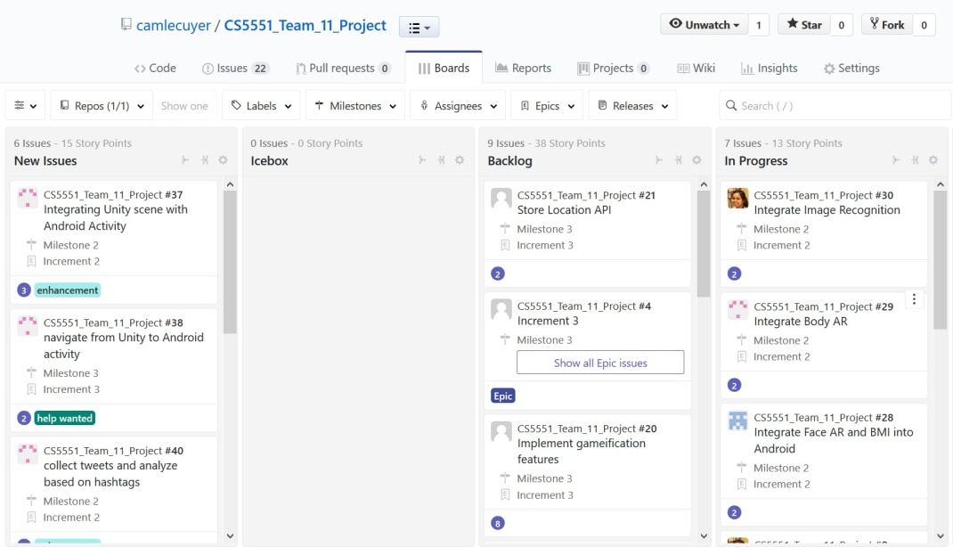

This is the burndown chart at about 3:30 PM on March 19 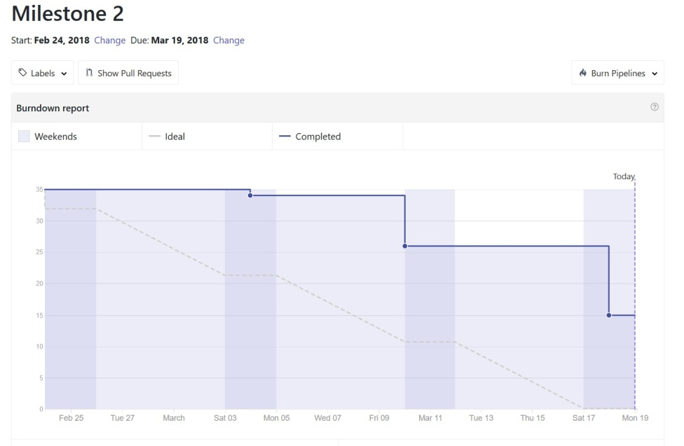

This is a screenshot of the closed issues at about 3:30 PM on March 19 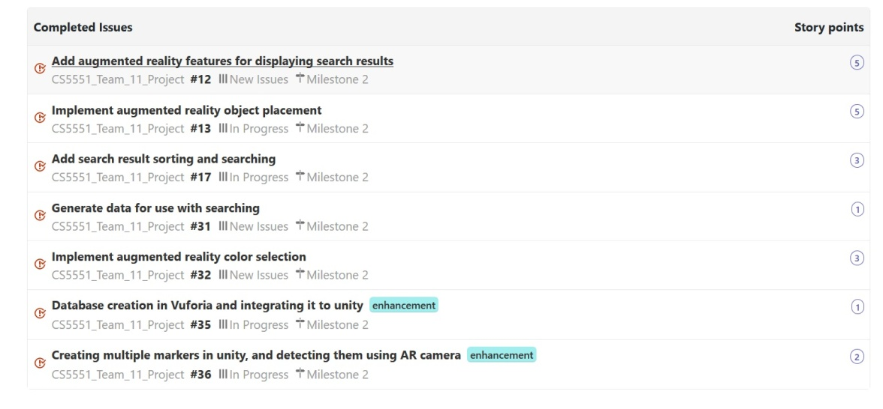

This is a screenshot of the open issues at about 3:30 PM on March 19 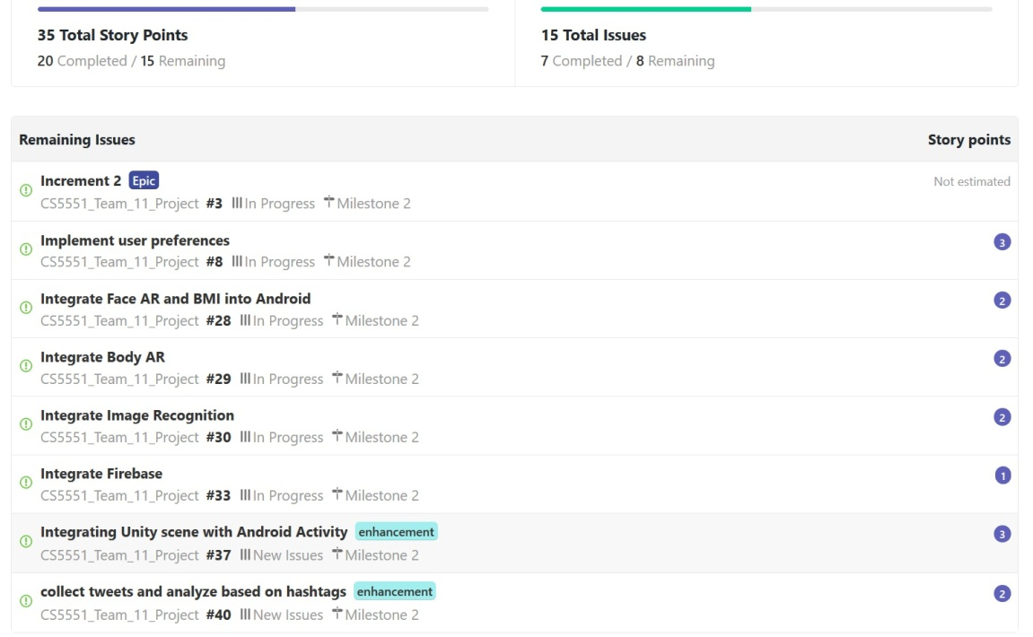

This is a user story for displaying search results 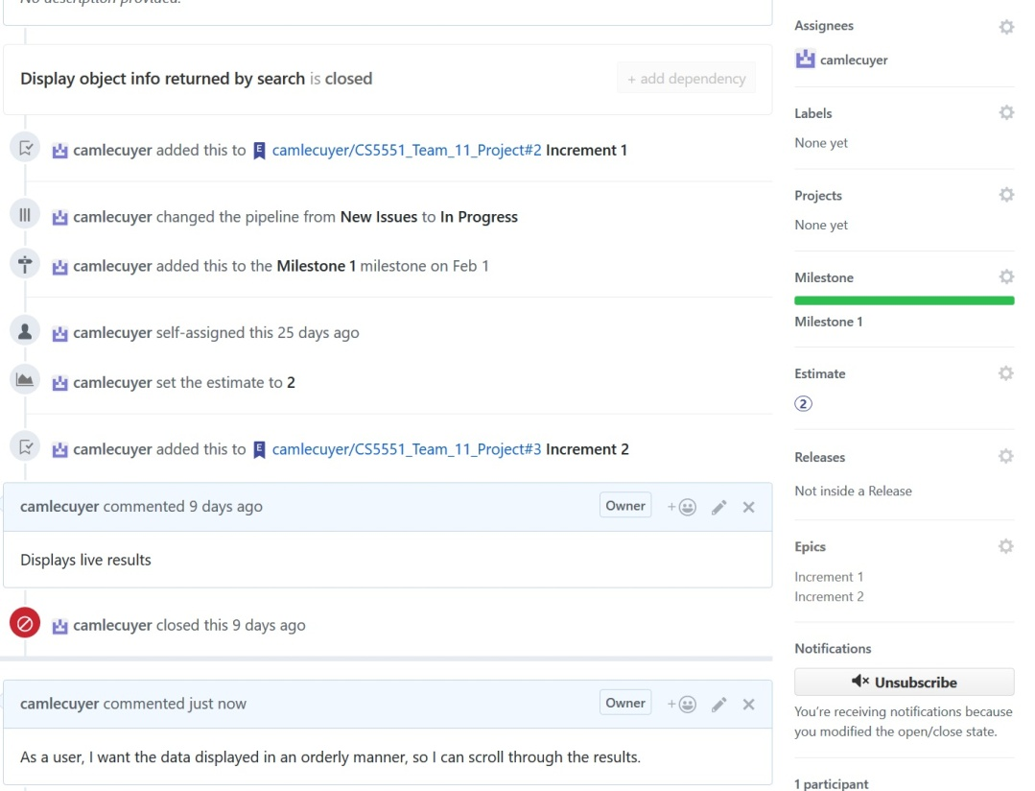

This is the burndown chart for Milestone 3 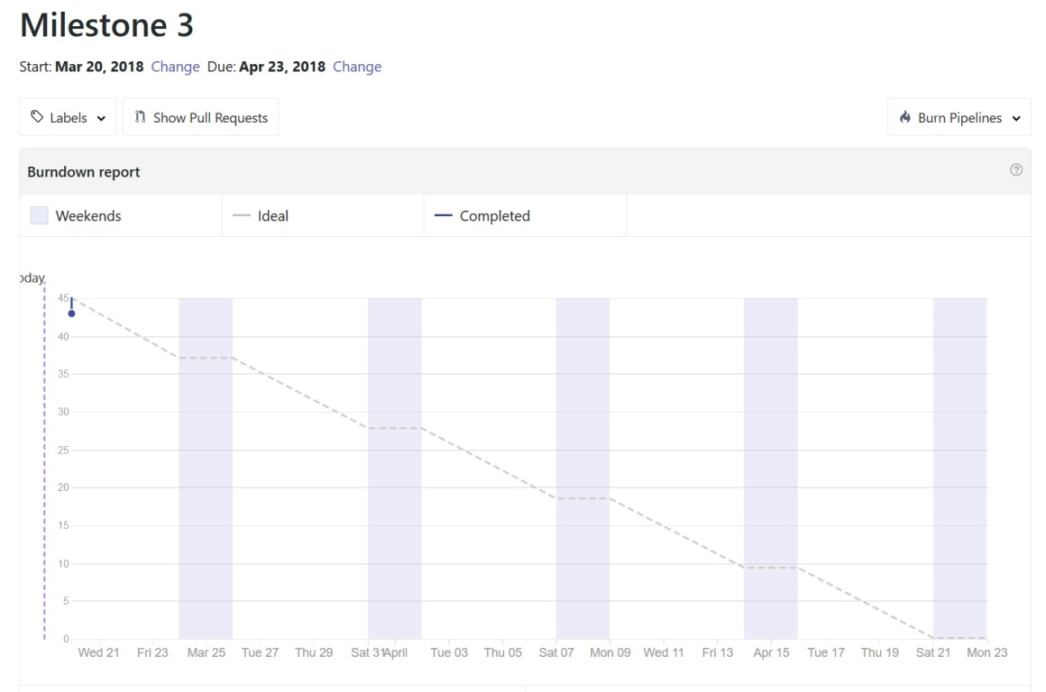

**4. Increment 2 Report**

* Each team member submitted what they had completed and the APIs/services they used
* Ruthvic created some of the UML diagrams and mock ups, Cameron created other mock ups

## 1. Existing Services/REST API

* <https://www.faceplusplus.com/body-outlining/#demo>
* <https://www.betafaceapi.com/wpa/>
* <https://stackoverflow.com/questions/21698044/basic-bmi-calculator-html-javascript>
* <https://azure.microsoft.com/en-us/services/cognitive-services/computer-vision/>
* Google Network Framework - Volley for Android
* Indix Product Search API

## 2. Detail Design of Features:

### UI Mockups

These Mock Ups were created by Cameron early in Increment 2, the pages in order are: login, face and BMI activity, search activity, body activity, and results activity 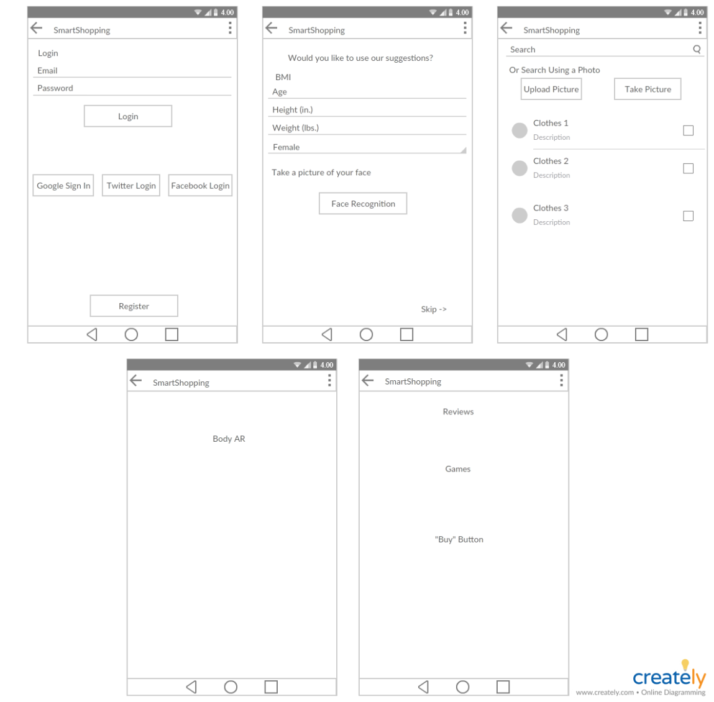

These Mock Ups were created by Ruthvic during Increment 1 This image shows what the favorites page may have looked like

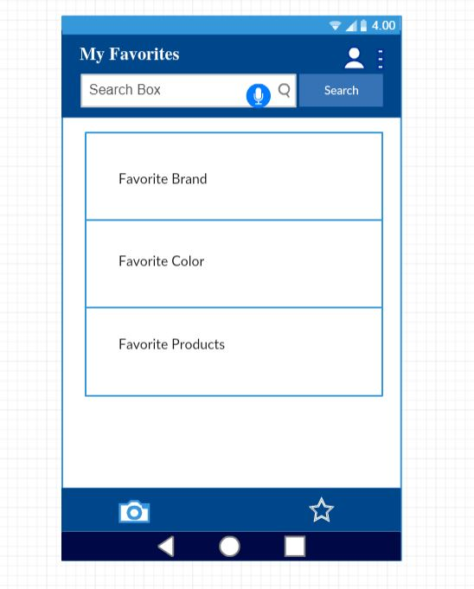

This image shows what the graphs created using social media data may look like 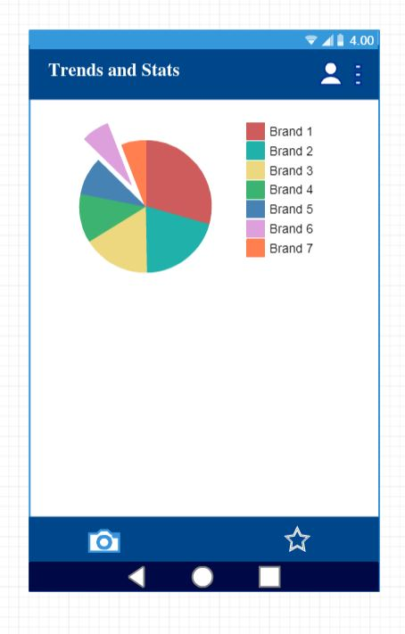

### UML

These were both created by Ruthvic This is the class diagram created during Increment 1 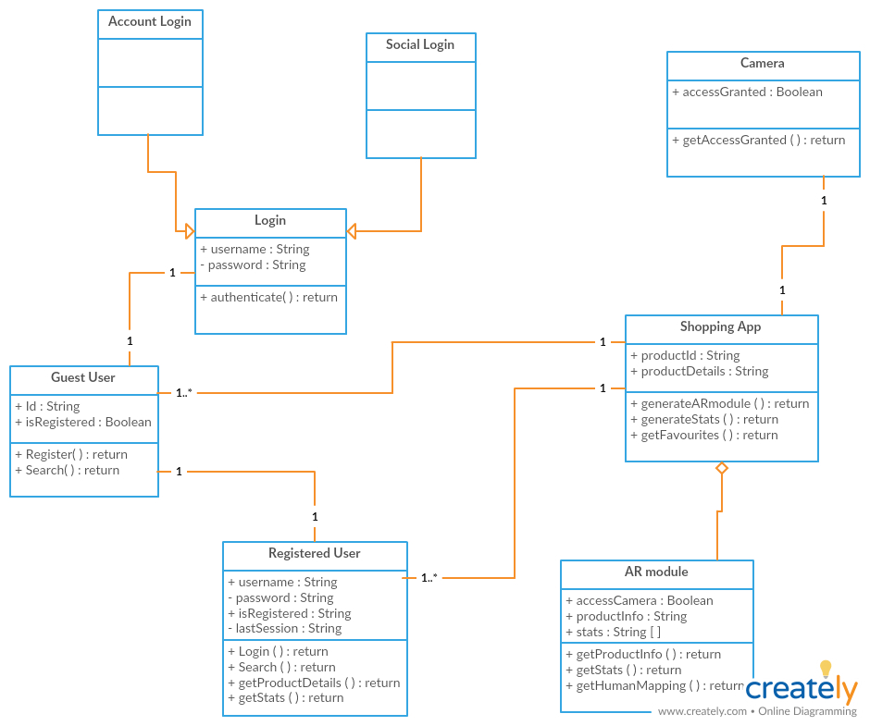

This is the sequence diagram for using our app, created during Increment 1 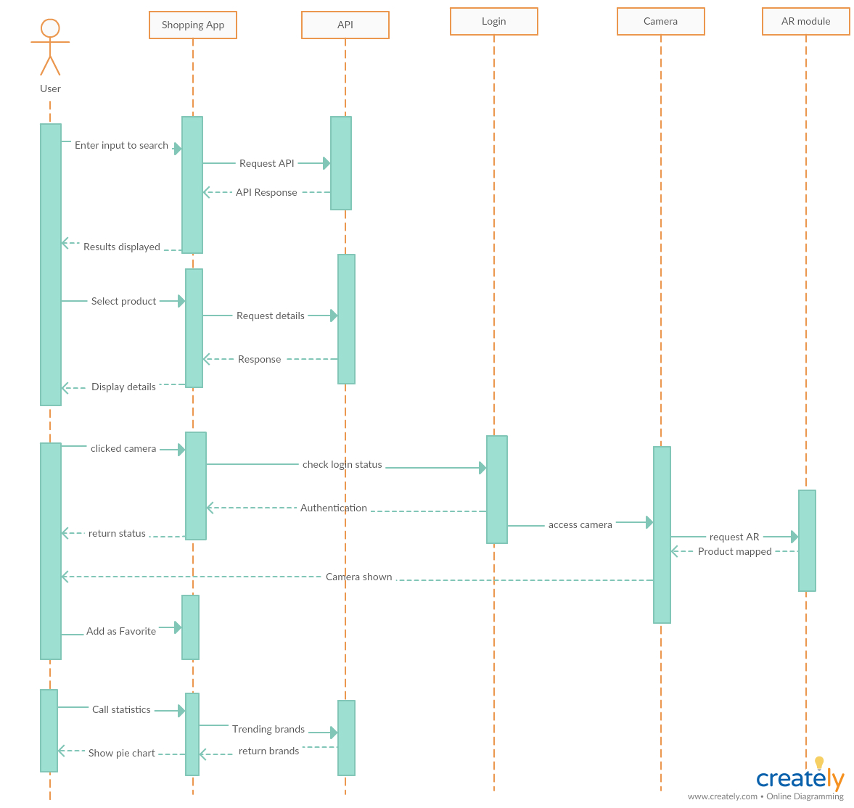

## 3. Testing

### Sneha:

Unit testing done to test the basic functionality of the image recognition Activity. Screenshots below indicate the activity transition.

Demo Login Page created to test successful Activity transition.  
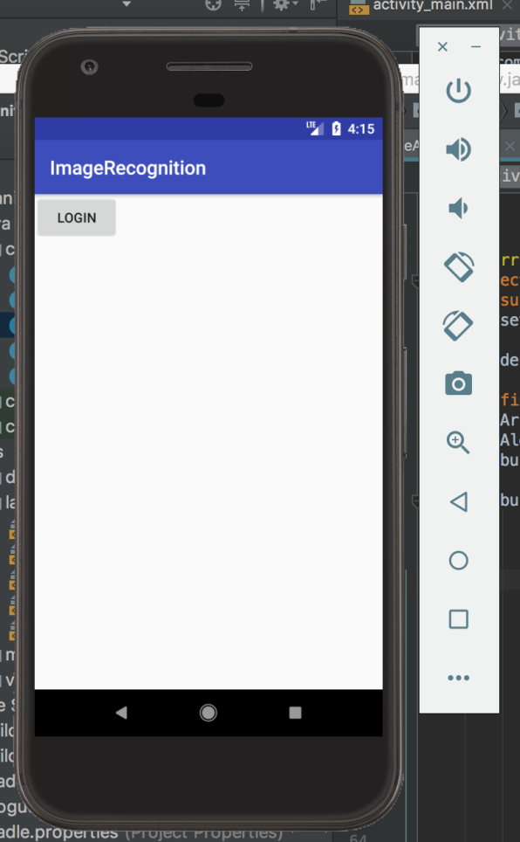

Home Page for the Image activity. Here the different buttons are used for different feature implementation.

* The back and skip is to allow user to move back to the login page or to skip the current image recognition activity and move directly to the shopping page.
* The capture button allows user to click a picture for image analysis.
* The select button allows user to select a pre-clicked image from the gallery.
* The analyze button will analyze the selected image using the Microsoft cognitive api.
* The shop button allows user to use the analysis in shopping.  
  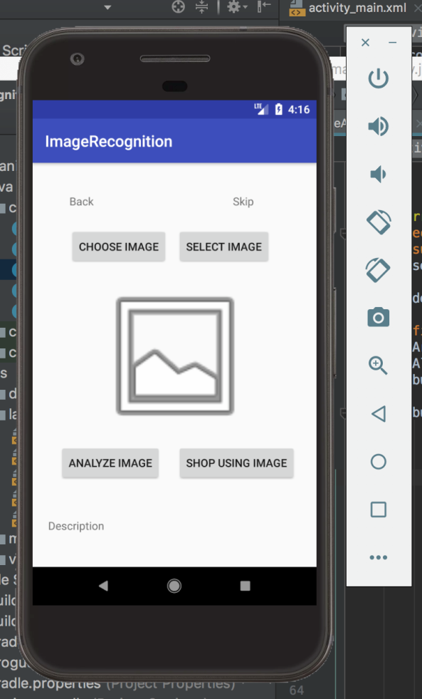

### Ruthvic:

Screen shot of android home page from which unity scene is called. The floating button is used to call the AR camera

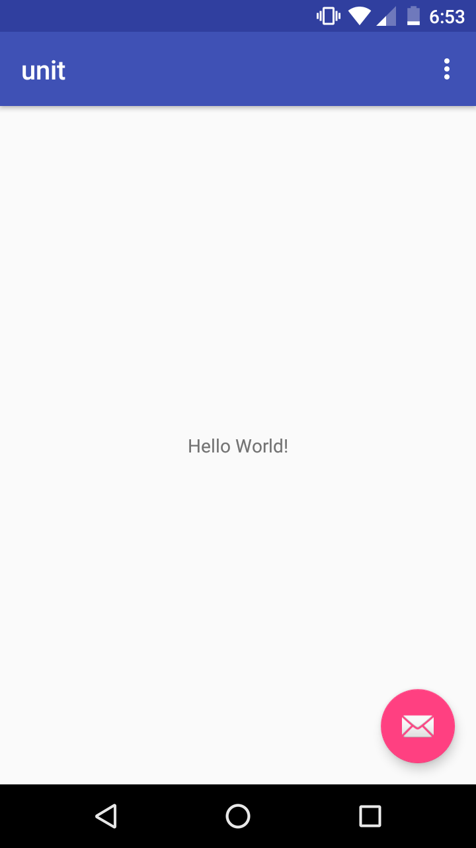

This navigates from android activity to unity scene, and initializes AR camera 

In unity, for the product to be displayed, I have used a currency note as a marker. Also used human body as a marker to project the 3d image of a shirt on to the body.



### Navya:

WEATHER APP THAT DISPLAYS CURRENT WEATHER

# WINTER

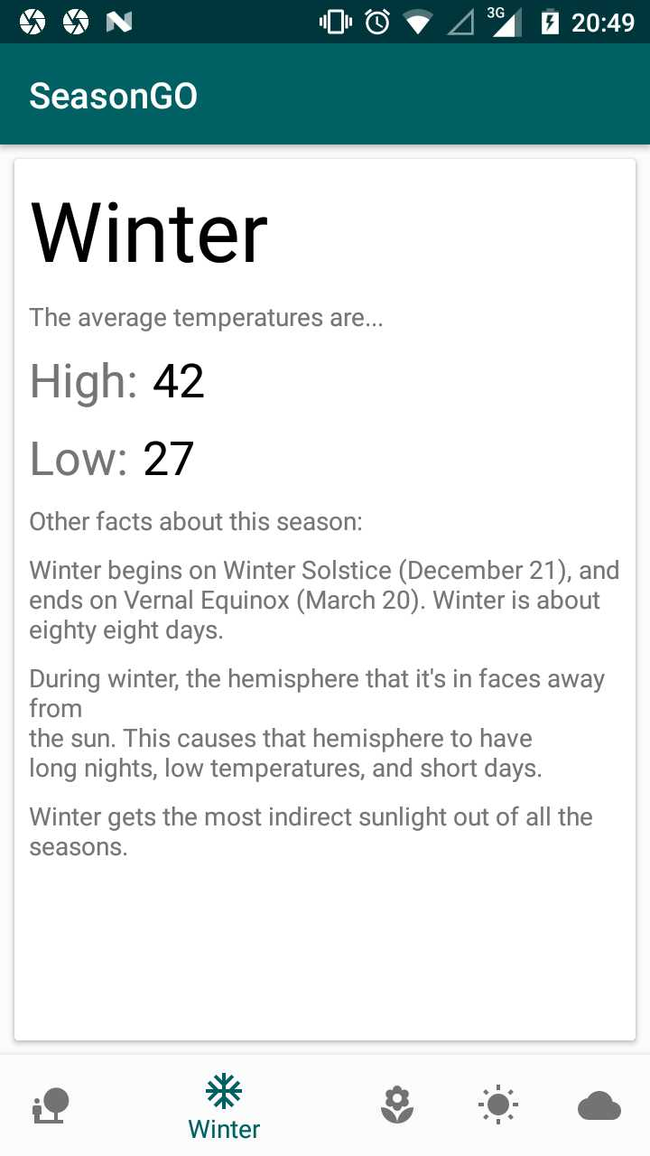

# SPRING

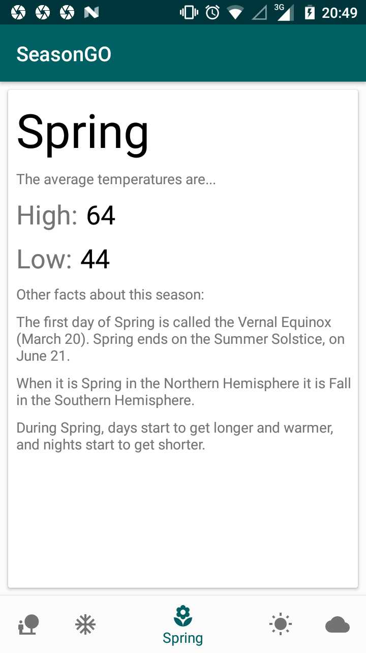

# SUMMER

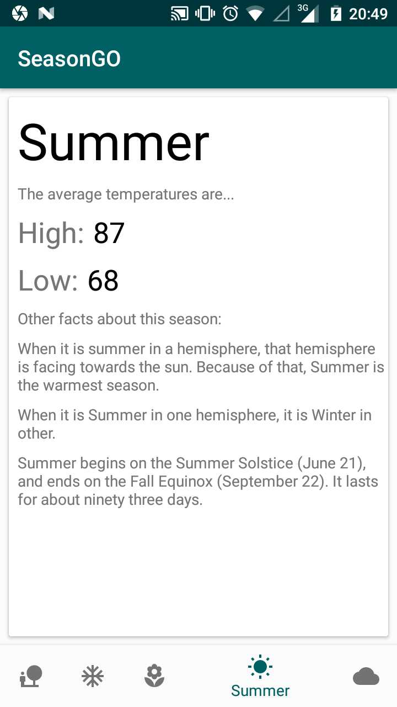

# FALL

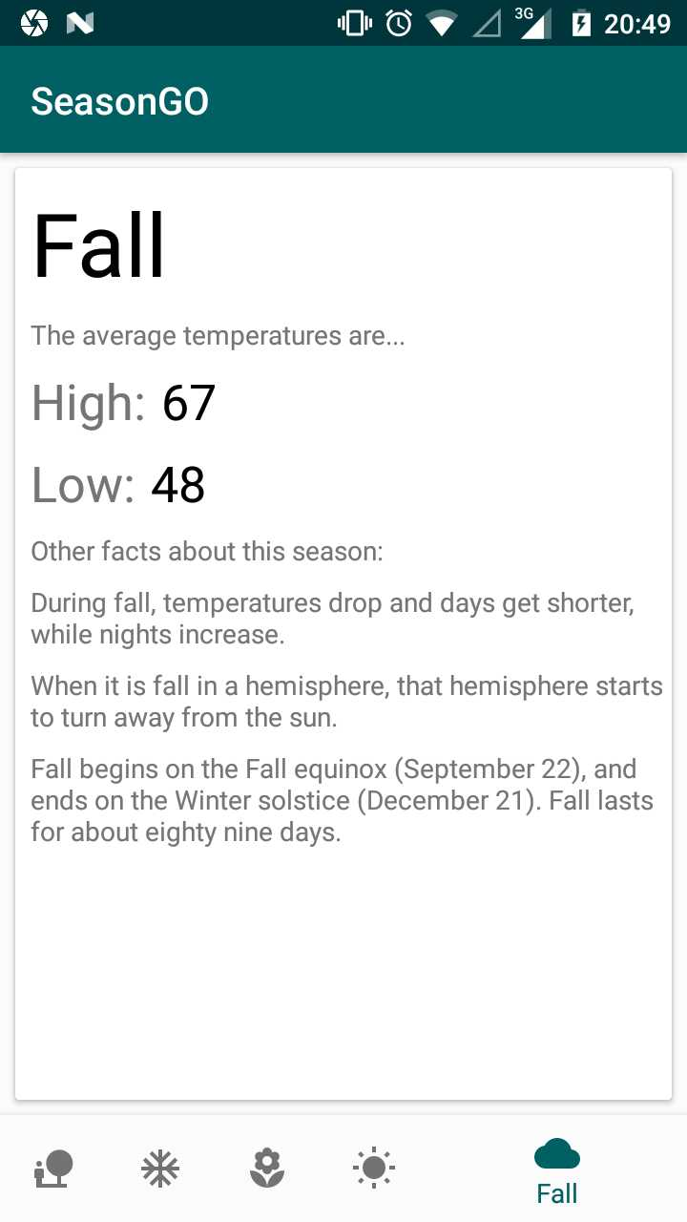

WEATHER APP THAT DISPLAYS CURRENT DAY WEATHER

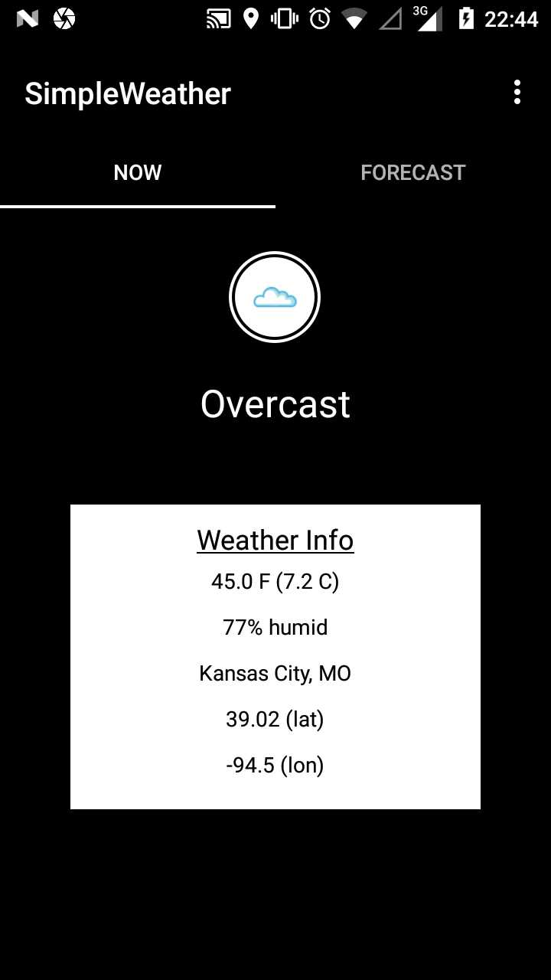

FORECAST OF WEATHER APP SHOWING THE WEATHER FOR NEXT THREE DAYS

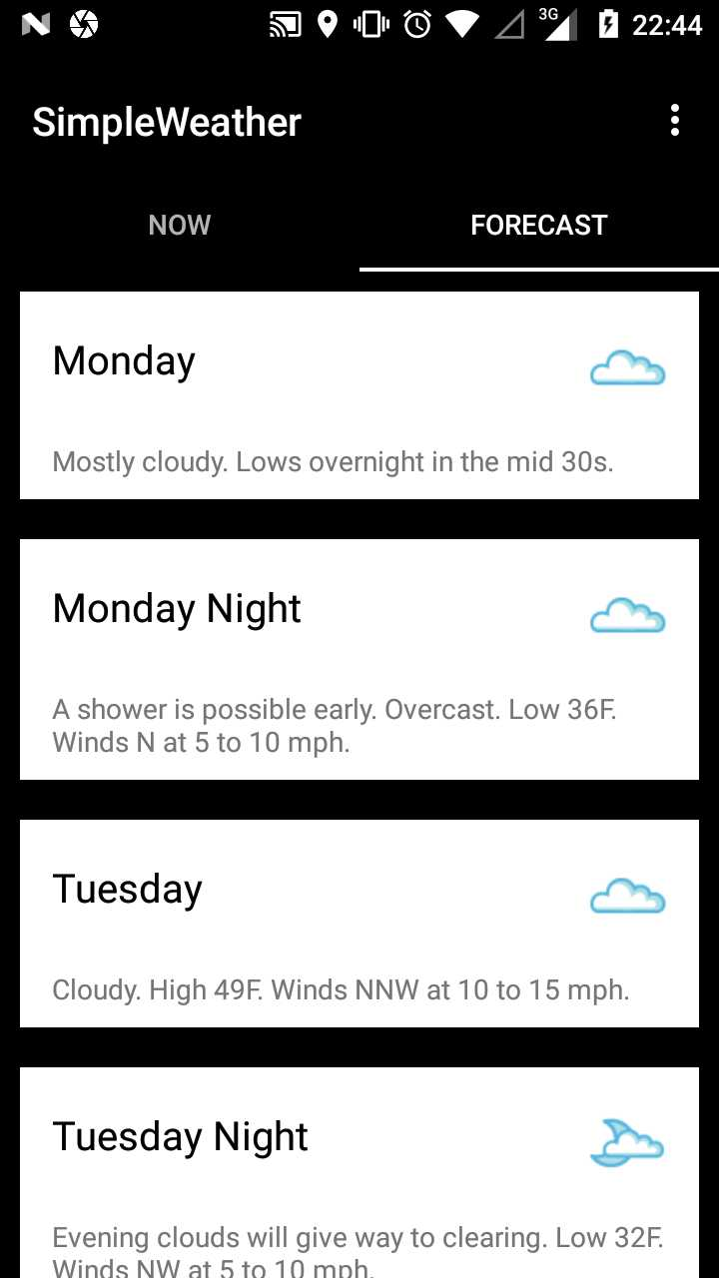

### Cameron:

This is a screenshot of testing being done, and failing, on the static database's getItem function 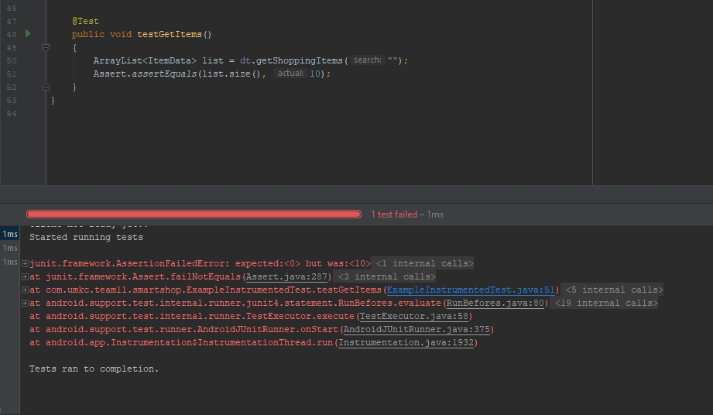

This is a screenshot of the same test, but of the test succeeding 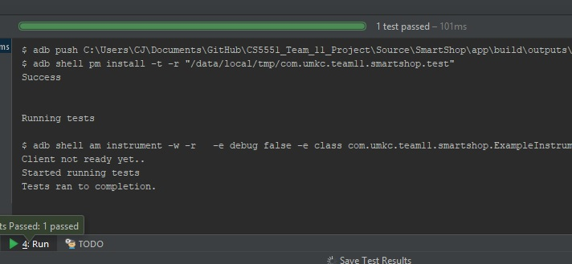

## 4. Deployment

### Sneha:

Hardware not available. Deployed on the emulator provided by android studio. Results are as shown in the screenshot below.

Image showing taking a picture.

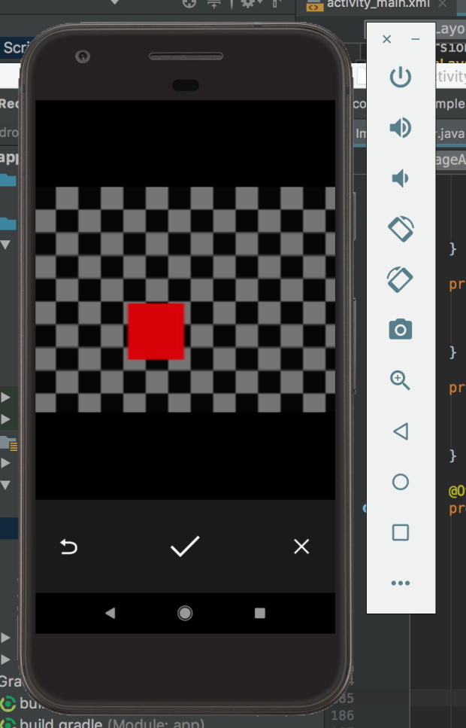

Displaying the clicked image

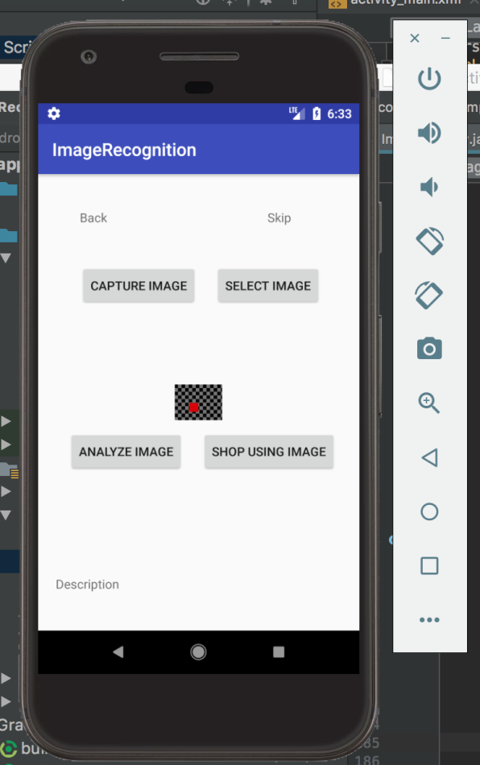

Selecting pre-clicked image from the gallery

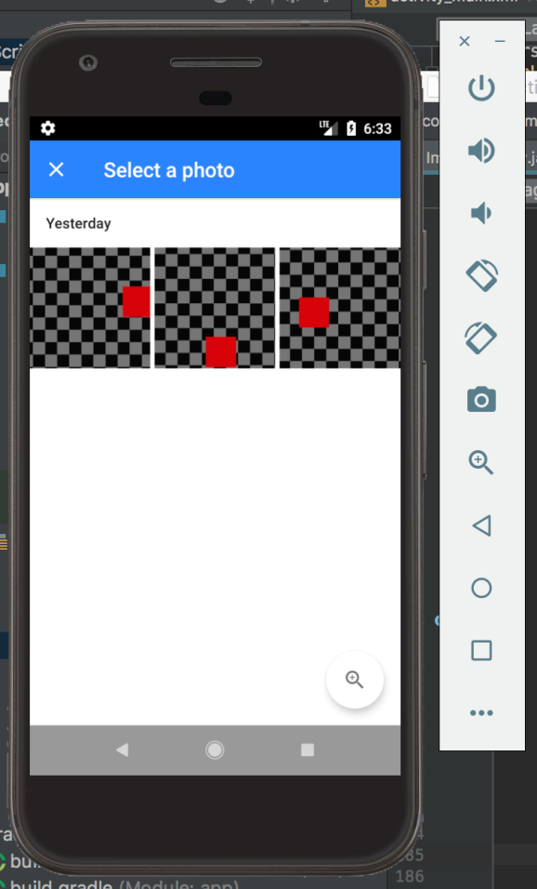

Displaying the selected image

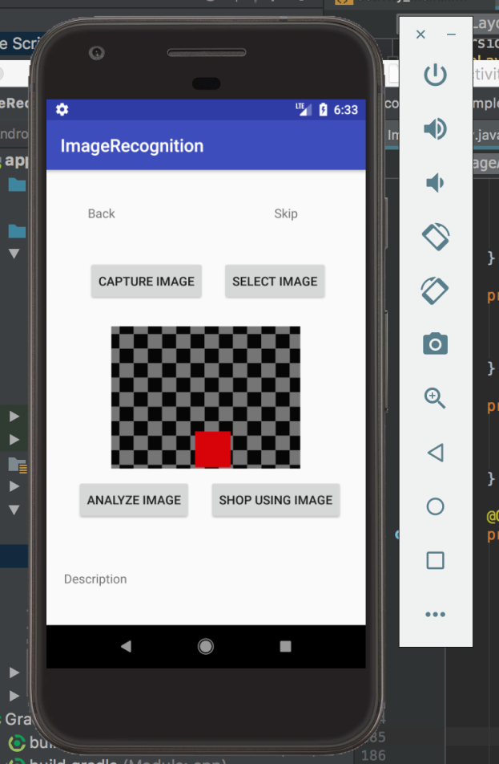

### Ruthvic:

The same screen shots are taken from the android device. So please refer to the above section

### Navya:

displays different seasons

# WINTER



# SPRING



# SUMMER



# FALL



WEATHER APP THAT DISPLAYS CURRENT DAY WEATHER



FORECAST OF WEATHER APP SHOWING THE WEATHER FOR NEXT THREE DAYS



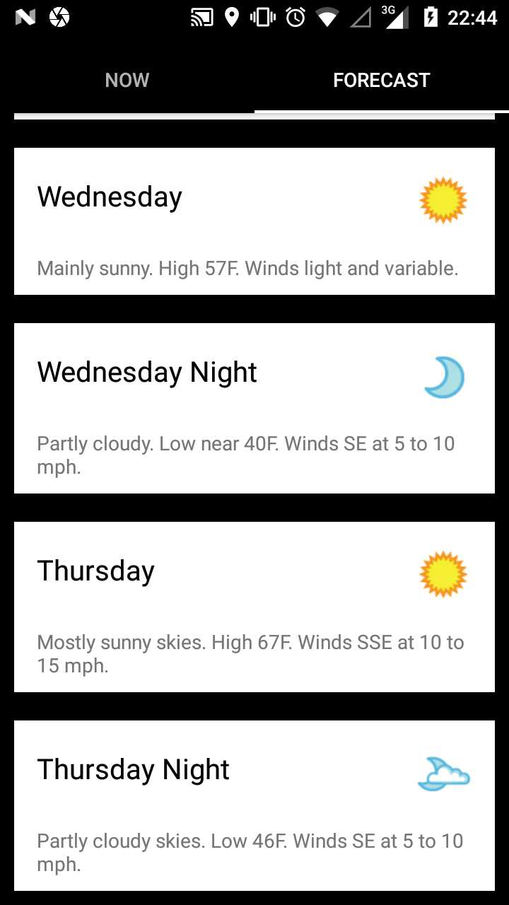

### Cameron:

This is screenshot of the shopping activity, which will allow the user to enter in a search term, and then sort it if they choose to  
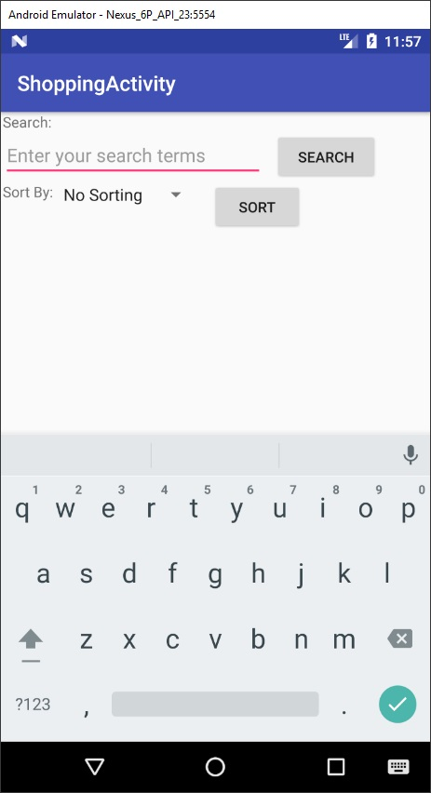

This is a screenshot taken after searching for a piece of clothing 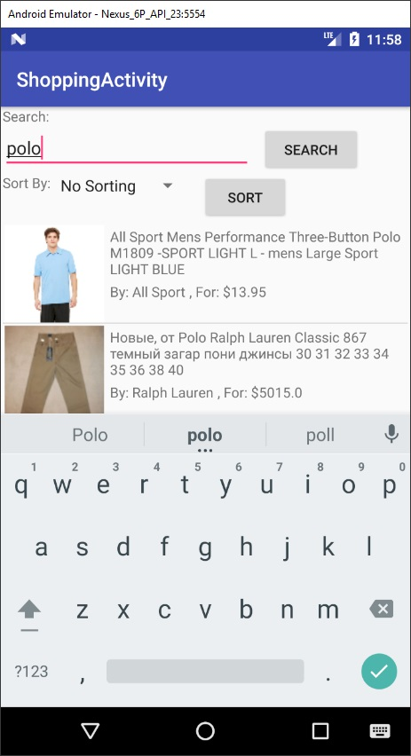

This screenshot shows the results after sorting by name

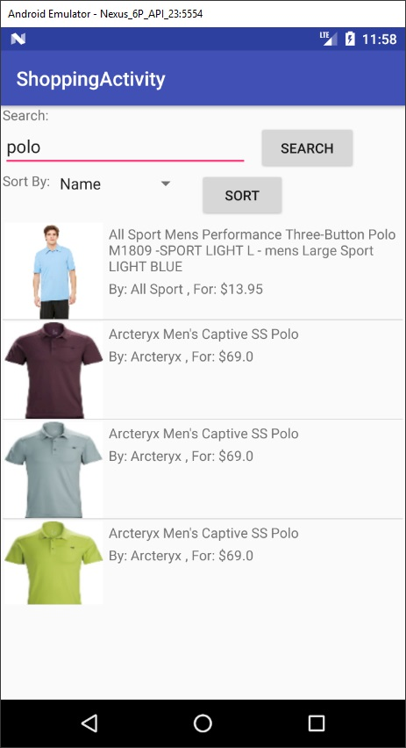

This shows the results after sorting by price

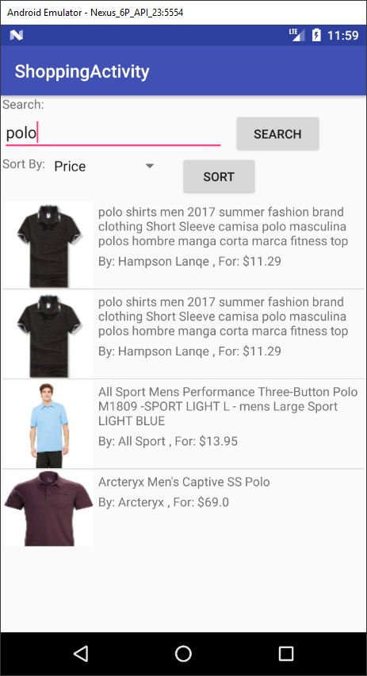

## 5. Project Management

### ****Work Completed****

### Sneha:

Currently the User can:

1. Move to the previous Activity
2. Skip the Image recognition activity to directly go to shopping page.
3. Take a picture for the image analysis
4. Upload the Image from the gallery for the analysis
5. Use the analysis to shop or move to shopping without the analysis. (In progress)
6. Get the analysis of the selected image.

### Ruthvic:

* Create a database in Vuforia with the 3d objects
* Link the database to unity assests, and build the scene
* Integrate AR camera instead of the default camera and set the image properties
* Create a marker and add it to scene and change the camera preferences and image transform
* Build and export it to android device
* Create a simple android home page from which the user has to navigate from activity to scene

### Navya:

* created weather app.
* According to the weather app it generates current weather as output.
* Basing on the weather the user will get suggestion of products which are preferable according to that weather.
* working on database that links the weather app to the shopping app.
* working on integrating weather app with the other modules of the project.
* also created simple weather app that displays the current weather conditions in that particular loaction, so that basing on that output user will get more appropriate suggestions.
* working on integrating season and weather app.

### Cameron:

* Gathered data and created a static database
* Implemented searching for an item by text
* Implemented selecting an item
* Implemented displaying results
* Found an API for searching for clothing, that can also search for furniture

### ****Work to be Completed****

### Sneha:

1. Share the image analysis data to the Shopping Activity.
2. Add User preference (if time permits).

### Ruthvic:

* Navigate from unity to android
* Unity button to take a screenshot of the camera view
* store the tweets count in mongo db

### Navya:

* build season app which gives the current season as output which allows user to choose products based on season and weather conditions.
* build weather app that displays current weather of that particular location.

### Cameron:

* None for Increment 2

# 5. Bibliography

* Amazon Shopping app: <https://play.google.com/store/apps/details?id=com.amazon.mShop.android.shopping&hl=en>
* IKEA Place: <https://itunes.apple.com/us/app/ikea-place/id1279244498?mt=8>
* IBM Watson: <https://www.ibm.com/watson/products-services/>
* Vuforia: <https://library.vuforia.com/api>
* ARToolKit: <https://www.artoolkit.org/documentation/>
* MaxST: <https://developer.maxst.com/>
* Amazon API: <https://docs.aws.amazon.com/AWSECommerceService/latest/DG/Welcome.html>
* Target API: <https://developer.target.com/>
* Walmart API: <https://developer.walmartlabs.com/>
* Google Speech-to-Text: <https://weston.ruter.net/2009/12/12/google-tts/>
* Indix API: <https://developer.indix.com/docs>
* Google Volley: <https://developer.android.com/training/volley/index.html>
* Microsoft Azure: <https://azure.microsoft.com/en-us/services/cognitive-services/computer-vision/>
* Unity tutorials : <https://docs.unity3d.com>